
LOGAN AUTO

Buy Now Vehicle List for Oct 28, 2025
NOTE***Chrysler/Ram/Jeep/Dodge vehicles are only guaranteed to have full warranty when you see CAN/AM warranty highlighted in yellow!

Year/Make/Model | 2024 FORD F-150 XLT CREW CAB SHORT BED 4WD SUPERCREW 5.5' BOX
Miles | 12,800 Miles
Engine | 3.5L 6CYL GASOLINE FUEL (Automatic Transmission)
Wheels | 18" (4 Wheel Drive)
Exterior Color | Black
Interior Color | Gray
Condition Report | 3.7

X | Navigation |  | Panorama Roof |  | Moon Roof |  | Sun Roof
 | Leather Seats |  | Heated Seats |  | Cooled Seats |  | Memory Seats
X | Back Up Cam |  | Remote Start |  | Rear Park Aid | X | Sat Radio
X | Blind Monitor |  | Blind Intervene | X | Heated Mirrors |  | Dual Zone A/C
 | Lane Depart |  | Power Hatch |  | Bed Liner | X | Run Boards
Note*** Additional Disclosure-08/07/2025-PoliceReportedAccident
Note*** Additional Disclosure-08/07/2025-$4,900-HistoryReport
Note*** ARS - FCCC Signature Plan Eligible
Note*** RIGHT QUARTER/SIDE Bed Side - R scratch heavy 9" to 10"
Note*** REAR Inside Bed mult scratches/heavy 4
Note*** INTERIOR Warning - Tire Pressure on
VIN | 1FTFW3L82RKE13339

Buy Now: $37,600
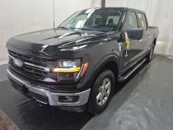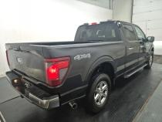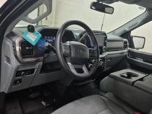

Year/Make/Model | 2023 FORD F-150 SUPER CREW STYLESIDE 4X4 LARIAT 4X4
Miles | 17,900 Miles
Engine | 6 CYLINDER 2.7 (Automatic Transmission)
Wheels | 275/60/20 (null)
Exterior Color | Avalanche Gray
Interior Color | Black
Condition Report | 4.8!

X | Navigation |  | Panorama Roof |  | Moon Roof | X | Sun Roof
X | Leather Seats | X | Heated Seats |  | Cooled Seats | X | Memory Seats
 | Back Up Cam |  | Remote Start | X | Rear Park Aid | X | Sat Radio
 | Blind Monitor |  | Blind Intervene |  | Heated Mirrors |  | Dual Zone A/C
 | Lane Depart |  | Power Hatch | X | Bed Liner | X | Run Boards
Note*** LEFT QUARTER PANEL paint depth
Note*** Right Quarter Panel paint depth
Note*** hood paint depth
Note*** left front door paint depth
Note*** left front fender paint depth
Note*** left rear door paint depth
Note*** right front door paint depth
Note*** right front fender paint depth
Note*** right rear door paint depth
Note*** roof paint depth
Note*** trunk/tailgate paint depth
VIN | 1FTEW1EP1PKF26877

Buy Now: $40,600
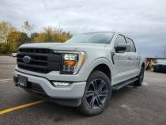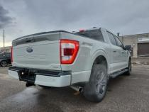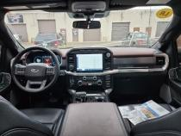

Year/Make/Model | 2023 FORD F-150 SUPER CREW STYLESIDE 4X4 XLT 4X4
Miles | 26,200 Miles
Engine | 6 CYLINDER 2.7 (Automatic Transmission)
Wheels | 265/70/17 (null)
Exterior Color | Infinite Black/agate Black Met
Interior Color | Gray
Condition Report | 3.8

X | Navigation |  | Panorama Roof |  | Moon Roof |  | Sun Roof
 | Leather Seats |  | Heated Seats |  | Cooled Seats |  | Memory Seats
 | Back Up Cam |  | Remote Start | X | Rear Park Aid |  | Sat Radio
 | Blind Monitor |  | Blind Intervene |  | Heated Mirrors |  | Dual Zone A/C
 | Lane Depart |  | Power Hatch | X | Bed Liner |  | Run Boards
Note*** LEFT QUARTER PANEL paint depth
Note*** Right Quarter Panel paint depth
Note*** hood paint depth
Note*** left front door paint depth
Note*** left front fender paint depth
Note*** left rear door paint depth
Note*** right front door paint depth
Note*** right front fender paint depth
Note*** right rear door paint depth
Note*** roof paint depth
Note*** trunk/tailgate paint depth
Note*** deck lid scratched 1X12.00" Scratched
Note*** front left tire cupping 1 Cupping
Note*** front right tire cupping 1 Cupping
Note*** front right tire flat 1 Flat
Note*** NOT all details are disclosed!! Please click on the link for full details...
VIN | 1FTEW1EP5PKF10682

Buy Now: $31,500
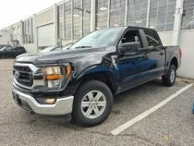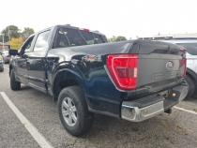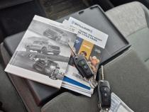

Year/Make/Model | 2023 FORD F-150 SUPER CREW STYLESIDE 4X4 XLT 4X4
Miles | 7,800 Miles
Engine | 6 CYLINDER 3.5 (Automatic Transmission)
Wheels | 275/60/20 (null)
Exterior Color | Infinite Black/agate Black Met
Interior Color | Black
Condition Report | 4.6

X | Navigation |  | Panorama Roof |  | Moon Roof |  | Sun Roof
 | Leather Seats | X | Heated Seats |  | Cooled Seats |  | Memory Seats
 | Back Up Cam |  | Remote Start | X | Rear Park Aid | X | Sat Radio
 | Blind Monitor |  | Blind Intervene |  | Heated Mirrors |  | Dual Zone A/C
 | Lane Depart |  | Power Hatch | X | Bed Liner | X | Run Boards
Note*** LEFT QUARTER PANEL paint depth
Note*** Right Quarter Panel paint depth
Note*** hood paint depth
Note*** left front door paint depth
Note*** left front fender paint depth
Note*** left rear door paint depth
Note*** right front door paint depth
Note*** right front fender paint depth
Note*** right rear door paint depth
Note*** roof paint depth
Note*** trunk/tailgate paint depth
Note*** deck lid scratched 2X40.00" Scratched
VIN | 1FTFW1E88PKE54296

Buy Now: $39,700
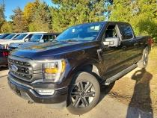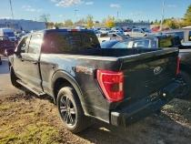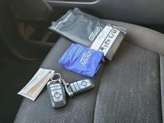

Year/Make/Model | 2023 FORD F-150 SUPER CREW STYLESIDE 4X4 XLT 4X4
Miles | 34,100 Miles
Engine | 6 CYLINDER 2.7 (Automatic Transmission)
Wheels | 275/65/18 (null)
Exterior Color | Infinite Black/agate Black Met
Interior Color | Gray
Condition Report | 3.6

X | Navigation |  | Panorama Roof |  | Moon Roof |  | Sun Roof
 | Leather Seats |  | Heated Seats |  | Cooled Seats |  | Memory Seats
 | Back Up Cam |  | Remote Start | X | Rear Park Aid | X | Sat Radio
 | Blind Monitor |  | Blind Intervene |  | Heated Mirrors |  | Dual Zone A/C
 | Lane Depart |  | Power Hatch |  | Bed Liner |  | Run Boards
Note*** LEFT QUARTER PANEL paint depth
Note*** Right Quarter Panel paint depth
Note*** hood paint depth
Note*** left front door paint depth
Note*** left front fender paint depth
Note*** left rear door paint depth
Note*** right front door paint depth
Note*** right front fender paint depth
Note*** right rear door paint depth
Note*** roof paint depth
Note*** trunk/tailgate paint depth
Note*** deck lid Scratched - buffable 1X0.12" Scratched - buffable
Note*** deck lid scratched 1X0.06" Scratched
Note*** left 1/4 panel Scratched - buffable 1X1.00" Scratched - buffable
Note*** left fender faded Faded
Note*** NOT all details are disclosed!! Please click on the link for full details...
VIN | 1FTEW1EP7PKE97806

Buy Now: $31,300
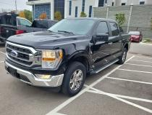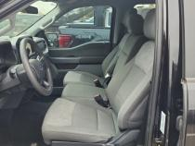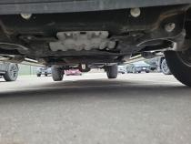

Year/Make/Model | 2023 FORD F-150 SUPER CREW STYLESIDE 4X4 LARIAT 4X4
Miles | 29,500 Miles
Engine | 6 CYLINDER 3.5 (Automatic Transmission)
Wheels | 275/60/20 (null)
Exterior Color | Azure Gray Tri-Coat
Interior Color | Black
Condition Report | 4.9!!

X | Navigation |  | Panorama Roof |  | Moon Roof |  | Sun Roof
X | Leather Seats | X | Heated Seats |  | Cooled Seats | X | Memory Seats
 | Back Up Cam |  | Remote Start | X | Rear Park Aid | X | Sat Radio
 | Blind Monitor |  | Blind Intervene |  | Heated Mirrors |  | Dual Zone A/C
 | Lane Depart |  | Power Hatch | X | Bed Liner | X | Run Boards
Note*** LEFT QUARTER PANEL paint depth
Note*** Right Quarter Panel paint depth
Note*** hood paint depth
Note*** left front door paint depth
Note*** left front fender paint depth
Note*** left rear door paint depth
Note*** right front door paint depth
Note*** right front fender paint depth
Note*** right rear door paint depth
Note*** roof paint depth
Note*** trunk/tailgate paint depth
Note*** front left wheel/cover gouged 1X0.12" Gouged
Note*** interior trim panels dirty Dirty
Note*** left 1/4 panel Scratched - buffable 1X0.50" Scratched - buffable
VIN | 1FTFW1E8XPFC58644

Buy Now: $43,400
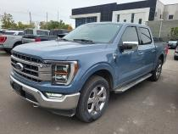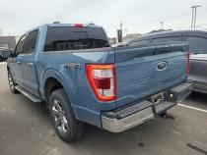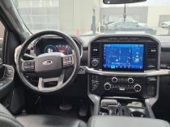

Year/Make/Model | 2023 FORD F-150 XLT CREW CAB SHORT BED 4WD SUPERCREW 5.5' BOX
Miles | 19,000 Miles
Engine | 2.7L 6CYL GASOLINE FUEL (Automatic Transmission)
Wheels | 18" (4 Wheel Drive)
Exterior Color | Gray
Interior Color | Gray
Condition Report | 4.5

X | Navigation |  | Panorama Roof |  | Moon Roof |  | Sun Roof
 | Leather Seats |  | Heated Seats |  | Cooled Seats |  | Memory Seats
X | Back Up Cam |  | Remote Start |  | Rear Park Aid | X | Sat Radio
X | Blind Monitor |  | Blind Intervene |  | Heated Mirrors |  | Dual Zone A/C
 | Lane Depart |  | Power Hatch |  | Bed Liner |  | Run Boards
Note*** INTERIOR Door Panel - LF mult scratches/heavy 3
Note*** INTERIOR Interior "B" Pillar Trim - R mult scratches/heavy 2
Note*** RIGHT QUARTER/SIDE Long Bed Side - R mult scratches/heavy 4
Note*** rear tailgate protective cap mult scratches/heavy Replacement Required
Note*** ARS - FCCC Signature Plan Eligible
Note*** Additional Disclosure-08/10/2025-PoliceReportedAccident
Note*** 2025-08-10, CLAIM, Undisclosed Amount
Note*** Additional Disclosure-08/13/2025-$3,800-HistoryReport
VIN | 1FTEW1EP0PFB76733

Buy Now: $35,100
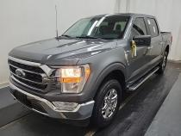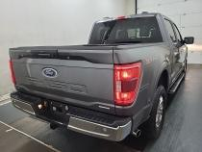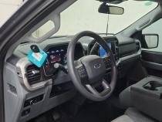

Year/Make/Model | 2023 FORD F-150 SUPER CREW STYLESIDE 4X4 LARIAT 4X4
Miles | 19,700 Miles
Engine | 6 CYLINDER 2.7 (Automatic Transmission)
Wheels | 275/60/20 (null)
Exterior Color | Oxford White
Interior Color | Black
Condition Report | 4.9!!

X | Navigation |  | Panorama Roof |  | Moon Roof |  | Sun Roof
X | Leather Seats | X | Heated Seats |  | Cooled Seats | X | Memory Seats
 | Back Up Cam |  | Remote Start | X | Rear Park Aid | X | Sat Radio
 | Blind Monitor |  | Blind Intervene |  | Heated Mirrors |  | Dual Zone A/C
 | Lane Depart |  | Power Hatch | X | Bed Liner | X | Run Boards
Note*** LEFT QUARTER PANEL paint depth
Note*** Right Quarter Panel paint depth
Note*** hood paint depth
Note*** left front door paint depth
Note*** left front fender paint depth
Note*** left rear door paint depth
Note*** right front door paint depth
Note*** right front fender paint depth
Note*** right rear door paint depth
Note*** roof paint depth
Note*** trunk/tailgate paint depth
VIN | 1FTEW1EP6PKF22260

Buy Now: $42,400
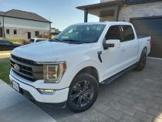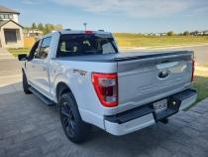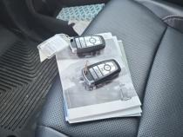

Year/Make/Model | 2023 FORD F-150 SUPER CREW STYLESIDE 4X4 LARIAT 4X4
Miles | 18,700 Miles
Engine | 6 CYLINDER 2.7L (Automatic Transmission)
Wheels | 275/60/20 (null)
Exterior Color | Avalanche Gray
Interior Color | Black
Condition Report | 4.5

X | Navigation |  | Panorama Roof |  | Moon Roof |  | Sun Roof
X | Leather Seats | X | Heated Seats |  | Cooled Seats | X | Memory Seats
 | Back Up Cam |  | Remote Start | X | Rear Park Aid | X | Sat Radio
 | Blind Monitor |  | Blind Intervene |  | Heated Mirrors |  | Dual Zone A/C
 | Lane Depart |  | Power Hatch | X | Bed Liner | X | Run Boards
Note*** LEFT QUARTER PANEL paint depth
Note*** Right Quarter Panel paint depth
Note*** hood paint depth
Note*** left front door paint depth
Note*** left front fender paint depth
Note*** left rear door paint depth
Note*** right front door paint depth
Note*** right front fender paint depth
Note*** right rear door paint depth
Note*** roof paint depth
Note*** trunk/tailgate paint depth
Note*** front bumper Dented / dinged - paint broken 1X1.00" Dented / dinged - paint broken
Note*** warning light stays on Stays on 1 1 SO
Note*** windshield aftermarket Aftermarket
VIN | 1FTEW1EP0PKF42035

Buy Now: $42,400
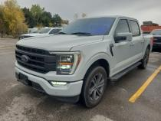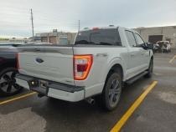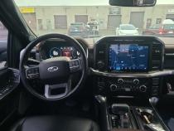

Year/Make/Model | 2023 FORD F-150 SUPER CREW STYLESIDE 4X4 LARIAT 4X4
Miles | 26,100 Miles
Engine | 6 CYLINDER 2.7 (Automatic Transmission)
Wheels | 275/60/20 (null)
Exterior Color | Avalanche Gray
Interior Color | Black
Condition Report | 4.3

X | Navigation |  | Panorama Roof |  | Moon Roof |  | Sun Roof
X | Leather Seats | X | Heated Seats |  | Cooled Seats | X | Memory Seats
 | Back Up Cam |  | Remote Start | X | Rear Park Aid | X | Sat Radio
 | Blind Monitor |  | Blind Intervene |  | Heated Mirrors |  | Dual Zone A/C
 | Lane Depart |  | Power Hatch | X | Bed Liner | X | Run Boards
Note*** LEFT QUARTER PANEL paint depth
Note*** Right Quarter Panel paint depth
Note*** hood paint depth
Note*** left front door paint depth
Note*** left front fender paint depth
Note*** left rear door paint depth
Note*** right front door paint depth
Note*** right front fender paint depth
Note*** right rear door paint depth
Note*** roof paint depth
Note*** trunk/tailgate paint depth
Note*** front left tire cupping 1 Cupping
Note*** front right tire cupping 1 Cupping
Note*** right 1/4 panel Dented / dinged - paint not broken 1X3.00" Dented / dinged - paint not broken
VIN | 1FTEW1EP4PKF64930

Buy Now: $41,400
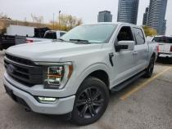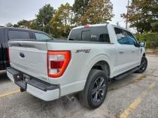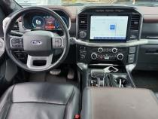

Year/Make/Model | 2023 FORD F-150 SUPER CREW STYLESIDE 4X4 LARIAT 4X4
Miles | 30,800 Miles
Engine | 6 CYLINDER 2.7 (Automatic Transmission)
Wheels | 275/60/20 (null)
Exterior Color | Infinite Black/agate Black Met
Interior Color | Black
Condition Report | 4.7

X | Navigation |  | Panorama Roof |  | Moon Roof |  | Sun Roof
X | Leather Seats | X | Heated Seats |  | Cooled Seats | X | Memory Seats
 | Back Up Cam |  | Remote Start | X | Rear Park Aid | X | Sat Radio
 | Blind Monitor |  | Blind Intervene |  | Heated Mirrors |  | Dual Zone A/C
 | Lane Depart |  | Power Hatch | X | Bed Liner | X | Run Boards
Note*** LEFT QUARTER PANEL paint depth
Note*** Right Quarter Panel paint depth
Note*** hood paint depth
Note*** left front door paint depth
Note*** left front fender paint depth
Note*** left rear door paint depth
Note*** right front door paint depth
Note*** right front fender paint depth
Note*** right rear door paint depth
Note*** roof paint depth
Note*** trunk/tailgate paint depth
Note*** left front door Dented / dinged - paint broken 1X1.00" Dented / dinged - paint broken
VIN | 1FTEW1EP4PKF02928

Buy Now: $41,100
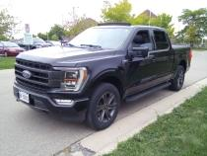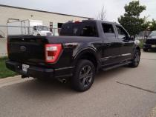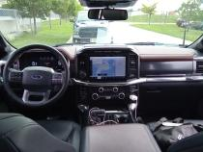

Year/Make/Model | 2023 FORD F-150 SUPER CREW STYLESIDE 4X4 LARIAT 4X4
Miles | 25,700 Miles
Engine | 6 CYLINDER 2.7 (Automatic Transmission)
Wheels | 275/55/20 (null)
Exterior Color | Infinite Black/agate Black Met
Interior Color | Black
Condition Report | 3.9

X | Navigation |  | Panorama Roof |  | Moon Roof |  | Sun Roof
X | Leather Seats | X | Heated Seats |  | Cooled Seats | X | Memory Seats
 | Back Up Cam |  | Remote Start | X | Rear Park Aid | X | Sat Radio
 | Blind Monitor |  | Blind Intervene |  | Heated Mirrors |  | Dual Zone A/C
 | Lane Depart |  | Power Hatch | X | Bed Liner | X | Run Boards
Note*** LEFT QUARTER PANEL paint depth
Note*** Right Quarter Panel paint depth
Note*** hood paint depth
Note*** left front door paint depth
Note*** left front fender paint depth
Note*** left rear door paint depth
Note*** right front door paint depth
Note*** right front fender paint depth
Note*** right rear door paint depth
Note*** roof paint depth
Note*** trunk/tailgate paint depth
Note*** deck lid scratched 1X3.00" Scratched
Note*** front bumper Dented / dinged - paint not broken 1X1.00" Dented / dinged - paint not broken
Note*** front left tire snow tire Snow tire
Note*** front right tire cupping 1 Cupping
Note*** NOT all details are disclosed!! Please click on the link for full details...
VIN | 1FTEW1EP4PKF18370

Buy Now: $40,900
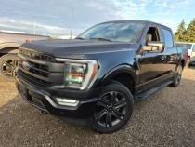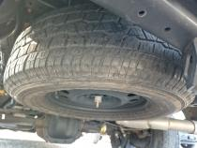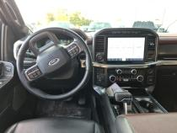

Year/Make/Model | 2023 FORD F-150 LARIAT CREW CAB SHORT BED 4WD SUPERCREW 5.5' BOX
Miles | 53,100 Miles
Engine | 3.5L 6CYL GASOLINE FUEL (Automatic Transmission)
Wheels | 20" (4 Wheel Drive)
Exterior Color | Black
Interior Color | Black
Condition Report | 3.4

X | Navigation | X | Panorama Roof |  | Moon Roof | X | Sun Roof
X | Leather Seats | X | Heated Seats | X | Cooled Seats | X | Memory Seats
X | Back Up Cam | X | Remote Start |  | Rear Park Aid | X | Sat Radio
X | Blind Monitor |  | Blind Intervene |  | Heated Mirrors |  | Dual Zone A/C
 | Lane Depart |  | Power Hatch |  | Bed Liner | X | Run Boards
Note*** INTERIOR Warning - Tire Pressure on Further Diagnosis
Note*** REAR Painted Metal Bumper - Rear bent GR 12"
Note*** RIGHT FRONT DOOR Door - RF scratch heavy 1" to 2"
Note*** front hood scratch heavy GR 12"
Note*** front roof scratch heavy GR 12"
Note*** rear tailgate mult scratches/heavy 3
Note*** ARS - FCCC Signature Plan Eligible
Note*** 3.5L V6
Note*** 2024-04-18, CLAIM, Undisclosed Amount
Note*** Additional Disclosure-04/18/2024-PoliceReportedAccident
Note*** Additional Disclosure-02/13/2025-PoliceReportedAccident
Note*** Additional Disclosure-02/13/2025-$6,200-HistoryReport
VIN | 1FTFW1E80PKD70361

Buy Now: $38,000
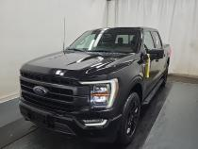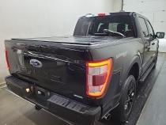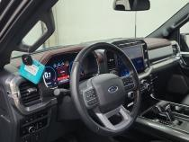

Year/Make/Model | 2023 FORD F-150 SUPER CREW STYLESIDE 4X4 XLT 4X4
Miles | 12,800 Miles
Engine | 6 CYLINDER 2.7 (Automatic Transmission)
Wheels | (null)
Exterior Color | Avalanche Gray
Interior Color | Black
Condition Report | 5.0!!!

X | Navigation |  | Panorama Roof |  | Moon Roof |  | Sun Roof
 | Leather Seats | X | Heated Seats |  | Cooled Seats |  | Memory Seats
 | Back Up Cam |  | Remote Start | X | Rear Park Aid | X | Sat Radio
 | Blind Monitor |  | Blind Intervene |  | Heated Mirrors |  | Dual Zone A/C
 | Lane Depart |  | Power Hatch | X | Bed Liner | X | Run Boards
Note*** LEFT QUARTER PANEL paint depth
Note*** Right Quarter Panel paint depth
Note*** hood paint depth
Note*** left front door paint depth
Note*** left front fender paint depth
Note*** left rear door paint depth
Note*** right front door paint depth
Note*** right front fender paint depth
Note*** right rear door paint depth
Note*** roof paint depth
Note*** trunk/tailgate paint depth
VIN | 1FTEW1EP7PKF28746

Buy Now: $38,500
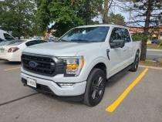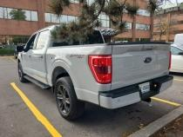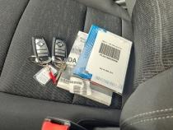

Year/Make/Model | 2023 FORD F-150 SUPER CREW STYLESIDE 4X4 LARIAT 4X4
Miles | 16,200 Miles
Engine | 6 CYLINDER 2.7 (Automatic Transmission)
Wheels | 275/60/20 (null)
Exterior Color | Infinite Black/agate Black Met
Interior Color | Black
Condition Report | 4.2

X | Navigation |  | Panorama Roof |  | Moon Roof | X | Sun Roof
X | Leather Seats | X | Heated Seats |  | Cooled Seats | X | Memory Seats
 | Back Up Cam |  | Remote Start | X | Rear Park Aid | X | Sat Radio
 | Blind Monitor |  | Blind Intervene |  | Heated Mirrors |  | Dual Zone A/C
 | Lane Depart |  | Power Hatch | X | Bed Liner | X | Run Boards
Note*** LEFT QUARTER PANEL paint depth
Note*** Right Quarter Panel paint depth
Note*** hood paint depth
Note*** left front door paint depth
Note*** left front fender paint depth
Note*** left rear door paint depth
Note*** right front door paint depth
Note*** right front fender paint depth
Note*** right rear door paint depth
Note*** roof paint depth
Note*** trunk/tailgate paint depth
Note*** left front door broken 1 Broken
VIN | 1FTEW1EP5PFC24341

Buy Now: $43,600
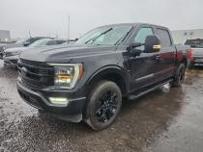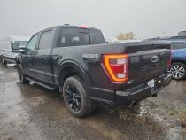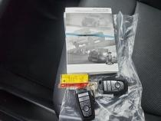

Year/Make/Model | 2025 FORD F-150 XLT CREW CAB SHORT BED 4WD SUPERCREW 5.5' BOX
Miles | 17,500 Miles
Engine | 2.7L 6CYL GASOLINE FUEL (Automatic Transmission)
Wheels | 20" (4 Wheel Drive)
Exterior Color | Black
Interior Color | Black
Condition Report | 4.9!!

X | Navigation |  | Panorama Roof |  | Moon Roof |  | Sun Roof
 | Leather Seats | X | Heated Seats |  | Cooled Seats |  | Memory Seats
X | Back Up Cam |  | Remote Start |  | Rear Park Aid | X | Sat Radio
X | Blind Monitor |  | Blind Intervene | X | Heated Mirrors |  | Dual Zone A/C
 | Lane Depart |  | Power Hatch |  | Bed Liner | X | Run Boards
Note*** ENREGISTREMENT 48 HEURES / REGS 48 HRS
Note*** ARS - FCCC Signature Plan Eligible
VIN | 1FTEW3LP0SFA43669

Buy Now: $41,800
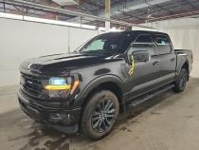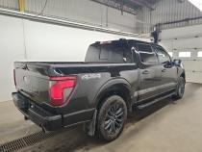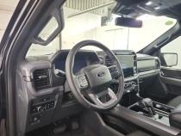

Year/Make/Model | 2023 FORD F-150 SUPER CREW STYLESIDE 4X4 XLT 4X4
Miles | 37,000 Miles
Engine | 6 CYLINDER 3.5 (Automatic Transmission)
Wheels | 275/60/20 (null)
Exterior Color | Oxford White
Interior Color | Black
Condition Report | 4.3

X | Navigation |  | Panorama Roof |  | Moon Roof | X | Sun Roof
 | Leather Seats | X | Heated Seats |  | Cooled Seats |  | Memory Seats
 | Back Up Cam |  | Remote Start | X | Rear Park Aid | X | Sat Radio
 | Blind Monitor |  | Blind Intervene |  | Heated Mirrors |  | Dual Zone A/C
 | Lane Depart |  | Power Hatch |  | Bed Liner | X | Run Boards
Note*** LEFT QUARTER PANEL paint depth
Note*** Right Quarter Panel paint depth
Note*** hood paint depth
Note*** left front door paint depth
Note*** left front fender paint depth
Note*** left rear door paint depth
Note*** right front door paint depth
Note*** right front fender paint depth
Note*** right rear door paint depth
Note*** roof paint depth
Note*** trunk/tailgate paint depth
Note*** deck lid Decal/Sticker non-commercial 1X9.00" Decal/Sticker non-commercial
Note*** deck lid damaged 1X0.12" Damaged
Note*** front bumper previous repair 1 Previous repair
Note*** windshield cracked 1X18.00" Cracked
VIN | 1FTFW1E80PKD36663

Buy Now: $36,800
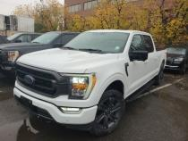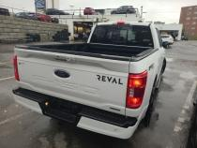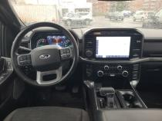

Year/Make/Model | 2025 BMW X5 XDRIVE40I SPORTS ACTIVITY VEHICLE
Miles | 24,500 Miles
Engine | 3.0L 6CYL GASOLINE/MILD ELECTRIC HYBRID (Automatic Transmission)
Wheels | 20" (All Wheel Drive)
Exterior Color | Black
Interior Color | Black
Condition Report | 3.6

X | Navigation | X | Panorama Roof |  | Moon Roof | X | Sun Roof
X | Leather Seats | X | Heated Seats |  | Cooled Seats | X | Memory Seats
X | Back Up Cam | X | Remote Start |  | Rear Park Aid | X | Sat Radio
X | Blind Monitor |  | Blind Intervene |  | Heated Mirrors |  | Dual Zone A/C
 | Lane Depart |  | Power Hatch |  | Bed Liner |  | Run Boards
Note*** LEFT FRONT DOOR Door - LF dent/no paint dmg 1" to 2"
Note*** RIGHT FRONT DOOR Door - RF mult scratches/heavy 3
Note*** RIGHT QUARTER/SIDE Wheel - RR peeling 3" to 4"
Note*** Required scheduled maintenance has been performed by BMW Retailers, vehicles remain under warranty and are CPO Eligible.
Note*** Located at OPENLANE Toronto
Note*** RIGHT FENDER Wheel - RF curb rash 3" to 4"
VIN | 5UX23EU02S9W24841
***Previous Daily Rental
Buy Now: $50,200
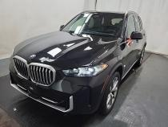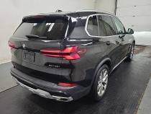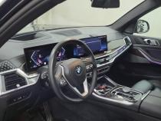

Year/Make/Model | 2023 LINCOLN AVIATOR GRAND TOURING AWD
Miles | 59,100 Miles
Engine | 3.0L 6CYL PLUG-IN ELECTRIC/GAS (Automatic Transmission)
Wheels | 21" (null)
Exterior Color | Gray
Interior Color | Tan
Condition Report | 3.6

X | Navigation | X | Panorama Roof |  | Moon Roof | X | Sun Roof
X | Leather Seats | X | Heated Seats |  | Cooled Seats | X | Memory Seats
X | Back Up Cam | X | Remote Start |  | Rear Park Aid | X | Sat Radio
X | Blind Monitor |  | Blind Intervene | X | Heated Mirrors |  | Dual Zone A/C
 | Lane Depart |  | Power Hatch |  | Bed Liner |  | Run Boards
Note*** FRONT Bumper Cover Partial - RF scuffed 3" to 4"
Note*** RIGHT FENDER Fender - RF scratch heavy 3" to 4"
Note*** ARS - FCCC Signature Plan Eligible
Note*** Additional Disclosure-02/01/2024-$5,600-HistoryReport
Note*** 4 Wheels - Curb Rash
VIN | 5LMYJ8XY6PNL01310

Buy Now: $38,000
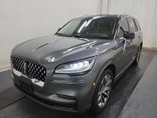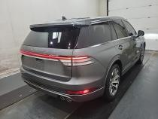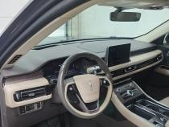

Year/Make/Model | 2023 FORD F-150 SUPER CREW STYLESIDE 4X4 LARIAT 4X4
Miles | 30,800 Miles
Engine | 6 CYLINDER 2.7 (Automatic Transmission)
Wheels | 275/60/20 (null)
Exterior Color | Pristine White / Star White
Interior Color | Black
Condition Report | 4.8!

X | Navigation |  | Panorama Roof |  | Moon Roof |  | Sun Roof
X | Leather Seats | X | Heated Seats |  | Cooled Seats | X | Memory Seats
 | Back Up Cam |  | Remote Start | X | Rear Park Aid | X | Sat Radio
 | Blind Monitor |  | Blind Intervene |  | Heated Mirrors |  | Dual Zone A/C
 | Lane Depart |  | Power Hatch | X | Bed Liner | X | Run Boards
Note*** LEFT QUARTER PANEL paint depth
Note*** Right Quarter Panel paint depth
Note*** hood paint depth
Note*** left front door paint depth
Note*** left front fender paint depth
Note*** left rear door paint depth
Note*** right front door paint depth
Note*** right front fender paint depth
Note*** right rear door paint depth
Note*** roof paint depth
Note*** trunk/tailgate paint depth
VIN | 1FTEW1EPXPFB77789

Buy Now: $43,500
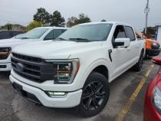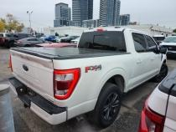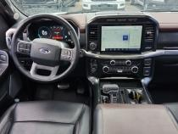

Year/Make/Model | 2023 FORD F-150 LARIAT CREW CAB SHORT BED 4WD SUPERCREW 5.5' BOX
Miles | 76,800 Miles
Engine | 2.7L 6CYL GASOLINE FUEL (Automatic Transmission)
Wheels | 20" (4 Wheel Drive)
Exterior Color | Gray
Interior Color | Black
Condition Report | 3.7

X | Navigation |  | Panorama Roof |  | Moon Roof | X | Sun Roof
X | Leather Seats | X | Heated Seats | X | Cooled Seats | X | Memory Seats
X | Back Up Cam | X | Remote Start |  | Rear Park Aid | X | Sat Radio
X | Blind Monitor |  | Blind Intervene |  | Heated Mirrors |  | Dual Zone A/C
 | Lane Depart |  | Power Hatch |  | Bed Liner | X | Run Boards
Note*** REAR Bumper Cover - Rear dent/paint dmg 3" to 4"
Note*** REAR License Plate Light - Rear inop Repair Required
Note*** REAR Tail Lamp - RR mult scratches/heavy Replacement Required
Note*** RIGHT FRONT DOOR Door - RF dent/no paint dmg 1" to 2"
Note*** rear tailgate scratch heavy 3" to 4"
Note*** rear tailgate protective cap mult scratches/heavy Replacement Required
Note*** ARS - FCCC Signature Plan Eligible
Note*** Additional Disclosure-05/10/2023-PoliceReportedAccident
Note*** Additional Disclosure-04/25/2024-PoliceReportedAccident
VIN | 1FTEW1EP0PKD84490

Buy Now: $33,700
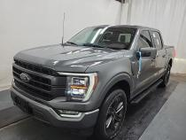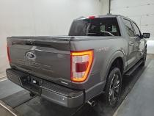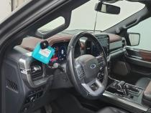

Year/Make/Model | 2024 BMW X5 XDRIVE40I SPORTS ACTIVITY VEHICLE
Miles | 31,600 Miles
Engine | 3.0L 6CYL GASOLINE/MILD ELECTRIC HYBRID (Automatic Transmission)
Wheels | 20" (All Wheel Drive)
Exterior Color | Black
Interior Color | Black
Condition Report | Unknown

X | Navigation | X | Panorama Roof |  | Moon Roof | X | Sun Roof
X | Leather Seats | X | Heated Seats |  | Cooled Seats | X | Memory Seats
X | Back Up Cam | X | Remote Start |  | Rear Park Aid | X | Sat Radio
X | Blind Monitor |  | Blind Intervene |  | Heated Mirrors |  | Dual Zone A/C
 | Lane Depart |  | Power Hatch |  | Bed Liner |  | Run Boards
Note*** RIGHT QUARTER/SIDE Wheel Opening Mldg - RR scratch heavy 1" to 2"
Note*** front hood scratch heavy 1" to 2"
Note*** PREVIOUS DAILY RENTAL / EX LOCATION JOURNALIERE
Note*** ENREGISTREMENT MANQUANT, AUCUNE DEPENSE REMBOURSEE, ARBITRATION DISPONIBLE DANS 8 JOURS / MISSING OWNERSHIP, NO EXPENSES WILL BE REFUNDED, ARBITRATION ALLOWED IN 8 DAYS.
VIN | 5UX23EU09R9V36430
***Previous Daily Rental
Buy Now: $48,900
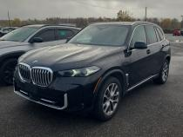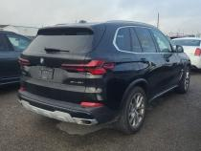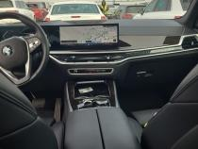

Year/Make/Model | 2024 FORD ESCAPE PHEV FWD
Miles | 20,000 Miles
Engine | 2.5L 4CYL PLUG-IN ELECTRIC/GAS (Automatic Transmission)
Wheels | 18" (Front Wheel Drive)
Exterior Color | Black
Interior Color | Gray
Condition Report | 4.1

X | Navigation |  | Panorama Roof |  | Moon Roof |  | Sun Roof
 | Leather Seats | X | Heated Seats |  | Cooled Seats |  | Memory Seats
X | Back Up Cam |  | Remote Start |  | Rear Park Aid | X | Sat Radio
X | Blind Monitor |  | Blind Intervene | X | Heated Mirrors |  | Dual Zone A/C
 | Lane Depart |  | Power Hatch |  | Bed Liner |  | Run Boards
Note*** LEFT FRONT DOOR Door VIN Sticker/ ID Label torn Replacement Required
Note*** REAR Bumper Cover - Rear broken Replacement Required
Note*** RIGHT FENDER Fender Liner - RF broken Replacement Required
Note*** ARS - FCCC Signature Plan Eligible
VIN | 1FMCU0E1XRUA46469

Buy Now: $24,900
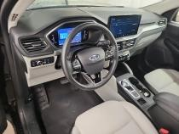

Year/Make/Model | 2023 RAM 1500 SPORT CREW CAB SHORT BED 4X4 CREW CAB 5'7" BOX
Miles | 51,200 Miles
Engine | 5.7L 8CYL GASOLINE/MILD ELECTRIC HYBRID (Automatic Transmission)
Wheels | 20" (4 Wheel Drive)
Exterior Color | Red
Interior Color | Black
Condition Report | Unknown

X | Navigation |  | Panorama Roof |  | Moon Roof |  | Sun Roof
X | Leather Seats | X | Heated Seats | X | Cooled Seats | X | Memory Seats
X | Back Up Cam | X | Remote Start |  | Rear Park Aid | X | Sat Radio
 | Blind Monitor |  | Blind Intervene |  | Heated Mirrors |  | Dual Zone A/C
 | Lane Depart |  | Power Hatch |  | Bed Liner | X | Run Boards
Note*** LEFT FENDER Fender - LF scratch heavy 3" to 4"
Note*** LEFT FRONT DOOR Door - LF scratch heavy 1" to 2"
Note*** LEFT QUARTER/SIDE Bed Side - L dent/no paint dmg 11" to 12"
Note*** MECHANICAL Air Filter Housing missing Replacement Required
Note*** REAR Bumper - Rear dent/paint dmg GR 12"
Note*** RIGHT FRONT DOOR Door - RF dent/paint dmg 2" to 3"
Note*** RIGHT FRONT DOOR Running Board - R broken Replacement Required
Note*** RIGHT QUARTER/SIDE Bed Side - R mult scratches/heavy 8
Note*** rear tailgate mult scratches/heavy 2
Note*** PREVIOUS DAILY RENTAL / EX LOCATION JOURNALIERE
Note*** ENREGISTREMENT MANQUANT, AUCUNE DEPENSE REMBOURSEE, ARBITRATION DISPONIBLE DANS 8 JOURS / MISSING OWNERSHIP, NO EXPENSES WILL BE REFUNDED, ARBITRATION ALLOWED IN 8 DAYS.
Note*** 2 Wheels - Curb Rash
VIN | 1C6SRFVT3PN516474
***Previous Daily Rental
Buy Now: $33,200
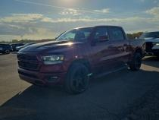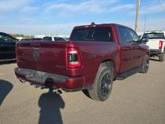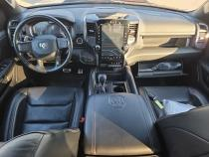

Year/Make/Model | 2023 FORD SUPER DUTY F-250 SRW LARIAT CREW CAB LONG BED 4WD CREW CAB 8' BOX
Miles | 31,500 Miles
Engine | 6.7L 8CYL DIESEL FUEL (Automatic Transmission)
Wheels | 18" (4 Wheel Drive)
Exterior Color | Black
Interior Color | Black
Condition Report | 3.6

X | Navigation |  | Panorama Roof |  | Moon Roof |  | Sun Roof
X | Leather Seats | X | Heated Seats | X | Cooled Seats | X | Memory Seats
X | Back Up Cam | X | Remote Start |  | Rear Park Aid | X | Sat Radio
X | Blind Monitor |  | Blind Intervene | X | Heated Mirrors |  | Dual Zone A/C
 | Lane Depart |  | Power Hatch |  | Bed Liner |  | Run Boards
Note*** INTERIOR Floor Mat - LR torn 2" to 3"
Note*** INTERIOR Warning - Tire Pressure on
Note*** LEFT FENDER Fender - LF dent/paint dmg 2" to 3"
Note*** LEFT FENDER Tire - LF mismatched Replacement Required
Note*** LEFT QUARTER/SIDE Bed Side - L prev repair Substd Sand Marks
Note*** LEFT QUARTER/SIDE Tire - LR mismatched Replacement Required
Note*** RIGHT FENDER Tire - RF gouged Replacement Required
Note*** RIGHT FENDER Tire - RF mismatched Replacement Required
Note*** RIGHT QUARTER/SIDE Center Cap - RR curb rash 3" to 4"
Note*** RIGHT QUARTER/SIDE Tire - RR mismatched Replacement Required
Note*** rear tailgate scratch heavy GR 12"
Note*** rear tailgate protective cap gouged 1" to 2"
Note*** ENREGISTREMENT MANQUANT / MISSING OWNERSHIP / AUCUNE DEPENSE PERMISE SUR CE VEHICULE / NO EXPENSE ARE PERMITTES ON THIS VEHICLE
Note*** ARS - FCCC Signature Plan Eligible
Note*** Warning - Tire Pressure Light On
VIN | 1FT7W2BT3PED81789

Buy Now: $64,100
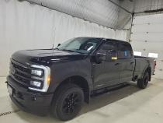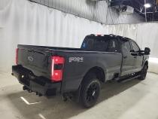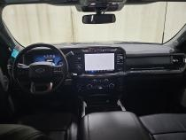

Year/Make/Model | 2020 FORD ESCAPE TITANIUM HYBRID AWD
Miles | 65,100 Miles
Engine | 2.5L 4CYL GAS/ELECTRIC HYBRID (Automatic Transmission)
Wheels | 19" (null)
Exterior Color | Gray
Interior Color | Black
Condition Report | 2.4

X | Navigation |  | Panorama Roof |  | Moon Roof | X | Sun Roof
X | Leather Seats | X | Heated Seats |  | Cooled Seats | X | Memory Seats
X | Back Up Cam | X | Remote Start |  | Rear Park Aid | X | Sat Radio
X | Blind Monitor |  | Blind Intervene | X | Heated Mirrors |  | Dual Zone A/C
 | Lane Depart |  | Power Hatch |  | Bed Liner |  | Run Boards
Note*** INTERIOR Door Panel - LR stained Permanent
Note*** LEFT FENDER Wheel - LF scratch heavy GR 12"
Note*** MECHANICAL Washer Fluid low fluid
Note*** RIGHT REAR DOOR Door - RR mult dents/paint dmg 5
Note*** front grille loose Repair Required
Note*** ARS - FCCC Signature Plan Eligible
Note*** Additional Disclosure-11/13/2020-$6,800-HistoryReport
Note*** Additional Disclosure-02/03/2022-$3,300-HistoryReport
Note*** Additional Disclosure-03/02/2022-$3,300-HistoryReport
Note*** Additional Disclosure-03/02/2022-PoliceReportedAccident
VIN | 1FMCU9DZ0LUC30788

Buy Now: $14,400
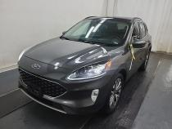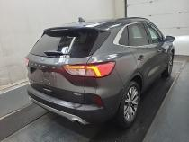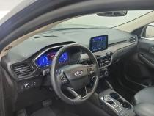

Year/Make/Model | 2022 RAM 1500 SPORT CREW CAB SHORT BED 4X4 CREW CAB 5'7" BOX
Miles | 46,700 Miles
Engine | 5.7L 8CYL GASOLINE FUEL (Automatic Transmission)
Wheels | 20" (4 Wheel Drive)
Exterior Color | Black
Interior Color | Black
Condition Report | 2.4

X | Navigation |  | Panorama Roof |  | Moon Roof |  | Sun Roof
 | Leather Seats | X | Heated Seats |  | Cooled Seats |  | Memory Seats
X | Back Up Cam |  | Remote Start |  | Rear Park Aid | X | Sat Radio
 | Blind Monitor |  | Blind Intervene | X | Heated Mirrors |  | Dual Zone A/C
 | Lane Depart |  | Power Hatch |  | Bed Liner | X | Run Boards
Note*** INTERIOR Seat Cushion - LF torn 1" to 2"
Note*** LEFT FRONT DOOR Door - LF mult dents/paint dmg 2
Note*** LEFT QUARTER/SIDE Bed Side - L dent/no paint dmg 1" to 2"
Note*** LEFT REAR DOOR Door - LR mult dents/paint dmg 2
Note*** MECHANICAL Wheel Housing - LR mult dents/paint dmg 10 or more
Note*** MECHANICAL Wheel Housing - RR mult dents/paint dmg 10 or more
Note*** REAR Inside Bed mult scratches/heavy 10 or more
Note*** RIGHT QUARTER/SIDE Bed Side - R mult scratches/heavy 10 or more
Note*** RIGHT QUARTER/SIDE Cab Side - R dent/paint dmg 1" to 2"
Note*** ARS - FCCC Signature Plan Eligible
Note*** LEFT QUARTER/SIDE Tire - LR worn Replacement Required
VIN | 1C6SRFVT2NN196657

Buy Now: $31,900
